3a)

Data:

Dividend Yield of S&P 500 Index in April 2009 = 2%

Risk Free Interest Rates Obtained from Treasury Web Site for T-Bills.

3b)

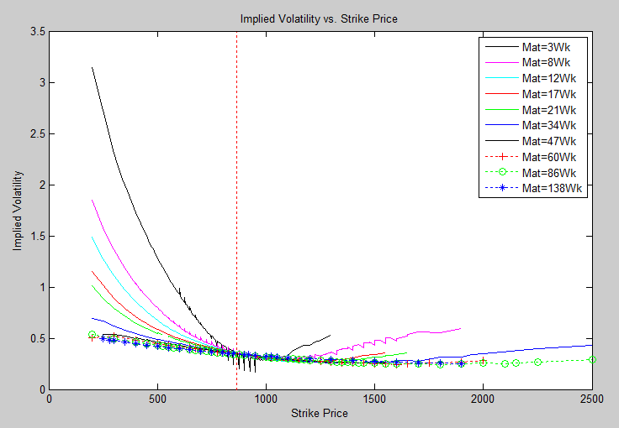

1) TBD: Unable to find historical volatility for S&P 500. Need to find.

2) Implied volatilities decrease with increasing strike price. It can also be seen that for a given strike price, options with shorter maturities have greater implied volatility. The term structure can be seen in the figure above and is a series of smiles.